CEO Report

Educating the Next Generation
Kiahra Moffett, a K-8 Erie Rise graduate, is off to a good start as a ninth grader at Villa Maria Academy High School.
Board of Trustees
Constance Ratcliff Ed Williams
Wayne Patterson Sonya Adams
Margaret Smith Shantel Hillard
Tim Kuzma Michael Hooks

October 15, 2020

Table of Contents

- Fall Operations
- Academic Updates
17. Human Resources/Compliance Report
17. RFO report

2020 – 2021 Fall Session
Fall Operations
- Erie Rise continues to monitor and enforce our Health and Safety Plan, and are thankful to report 10 weeks (counting the summer session) of COVID free face to face instruction for a portion of our Special Education students and middle school students attending for additional help. Erie Rise is committed to updating our Health and Safety Plan to match the latest public health information to ensure the safety of our students and staff.
- Work continues on developing the data base necessary to build the school’s time and attendance program. Details are forthcoming on a possible launch date once all the data has been gathered and a custom version of Kronos time and attendance has been built for Erie Rise.
- There are no updates at this time regarding the school’s ventilation system. As information becomes available it will be shared with the Board and GECAC.
- A light breakfast and lunch is being provided in the school for the student’s attending on a daily basis. Saturday schools are being conducted remotely until school resumes in November.
- Erie Rise is working with 3i and exploring opportunities within our community to better service families that would benefit from the educational services offered at the school.
- The 21st Century after school program has resumed. The program started on the 5th of October and will run for nine months concluding on the 5th of June.
- The school is requesting to change our Phased School Reopening Health and Safety Plan, to reflect moving our start date back to November 9th and making the changes outlined in our New Return Plan.

ERLACS Board of Trustees Meeting 10/15/2020

Academic Updates
Erie Rise leadership academy Charter

Participation/Attendance Update
Erie Rise Leadership Academy Charter School has been continuously improving its participation/attendance since the first day of school. The first week of school displayed an average of 74% overall participation/attendance whole school. Due to targeted communication and support efforts, ERLACS has improved its participation/attendance by 10% over 5 weeks to 84% whole school.

The teachers and administration will continue to support students and parents to the best of their ability to further increase participation/attendance.

Connectivity
Google Classroom & Packet Participation
ERLACS is utilizing Google Classroom as its online learning platform for Kindergarten – 8th Grade. Print packet materials are also available for families who do not have internet access or by parent request. Overall, 94% of ERLACS students are receiving instruction online via Google Classroom, while only 6% are receiving the print packet materials.
The majority of the 6% receiving print packet materials do not have access to personal Wi-Fi. ERLACS is exploring options to provide families in need with hotspots to access the internet and the online platforms.

Parent Survey Results
In order to obtain more information relative to our families’ needs, Ms. Dunston and Mrs. McCaughtry put together a Parent Survey with the help of Dr. Smith which was sent to parents electronically via the Rise Facebook and Class Dojo page. Additionally, paper copies of the survey were sent home with our students who receive Special Education services that returned to the building. The survey was divided into two sections: Google Classroom Specific Questions and Print Packet Material Specific Questions. Forty families, totaling 78 students, responded to the survey.
Addressing The Results
The ERLACS administration has carefully reviewed the results of this survey and is in the process of or has already implemented the following solutions:
- Purchasing additional technology to support families with multiple students
- Providing additional technical support via phone calls, home visits, video-chats, and in-person visits to the school building in a safe and controlled manner
- Posting targeted and requested how-to video tutorials to the school’s Facebook and Class Dojo pages for parents and students to view for help navigating the online platforms
- Creating a 21st Century Google Classroom page that can be accessed 24/7 where parents can submit requests for support, access information about resources within the community (free meals, job training, resume writing, WIC, Crime Victim Center, etc.), view how-to video tutorials to better assist their students with online learning, and receive assistance/tutoring after-school hours, and so much more

Benchmark Testing
The administration of ERLACS recognizes the need to begin/continue diagnostic and benchmark testing of all students in order for teachers to make appropriate and data-driven decisions regarding their instruction to best serve our students.
The administrative team has developed a plan/schedule to bus students to Erie Rise to administer the following assessments in a controlled environment: CDT, DIBELS, EasyCBM Reading, and EasyCBM Math. Testing would be provided in a morning session and an afternoon session. The morning session would take place from 8:00am – 10:30am and the afternoon session would take place from 12:00pm – 2:30pm. If ERLACS can secure additional buses, testing will begin on Tuesday, October 13, and will conclude on Wednesday, November 4, as follows:
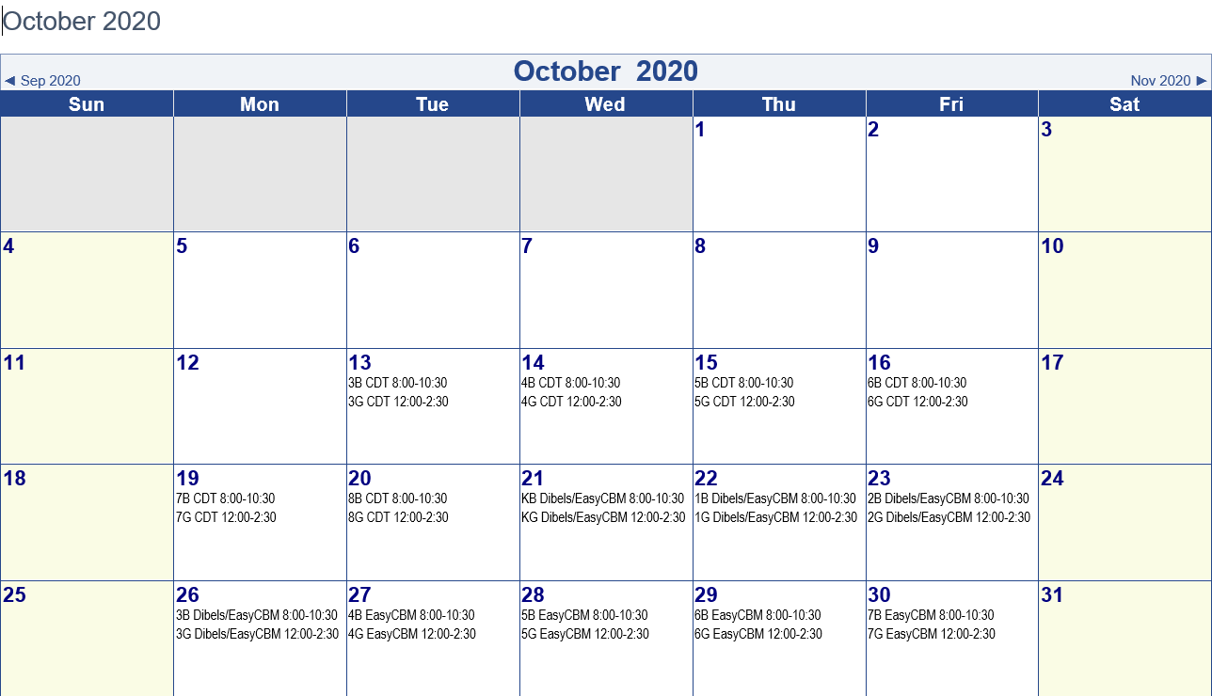

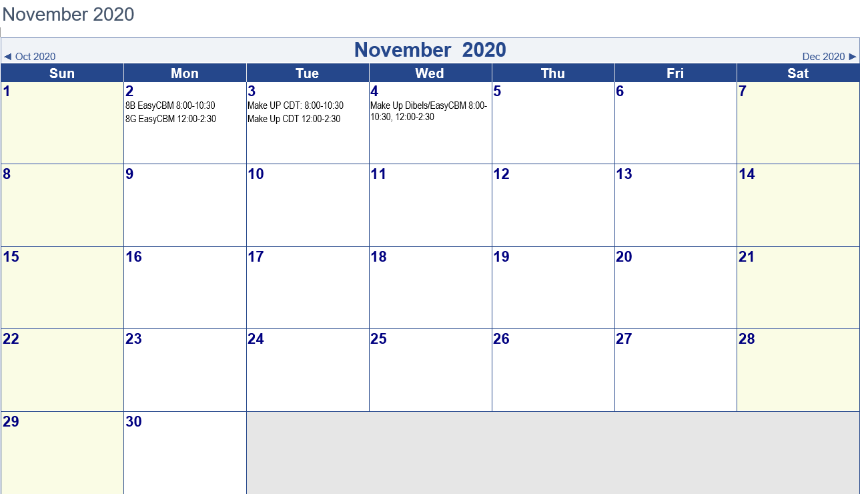

Special Education Services Update
All students who receive Special Education Services at Erie Rise were given the option to attend school to receive face-to-face instruction from their Special Education teachers. Of the 82 total students who receive Special Education Services at Erie Rise, 61 students have been in the building from 10:00am – 2:00pm daily receiving targeted intervention through small-group instruction to meet their IEP goals. Once IEP minutes have been met, teachers are assisting students with select content through their Google Classrooms.
The Special Education teachers are supporting all of the Special Education students either in-person (61) or remotely (21). The 21 students whose parents have chosen not to send their students into the building for face-to-face instruction are still receiving Special Education services virtually with separate zoom meetings and through home visits, phone calls or texts with daily contact from the Special Education teachers/case managers.
Additionally, the Special Education team has completed the screening process of gathering baseline data on all students present through a progress-monitoring tool, Fastbridge. The students will receive monitoring over a six-week period to determine whether a student has any academic deficits due to the COVID-19 extended school closure. Any student who displays a deficit will receive a Recoupment Plan though the IEP which outlines specific interventions to reduce the academic gap, per state guidelines. We have had no need for any recoupment plans at this time.
Notices of Recommended Educational Placement (NOREP) have been adjusted for the 61 students who are present. There have been modifications to adjust for any school model we need or chose to use in the future. We are continuing to invite the Special Education students into the building.

Human Resources/Compliance Report
October 15, 2020

- Human Resources is seeking to fill the following positions:

School Psychologist | Seth Hembree

Erie Rise Leadership Academy Charter School
Rise Family Organization Update
October 15, 2020

Special Programs/Activities:

- The RFO/Title I Calendar has been established for the FY 2020/2021 Academic Year. RFO Meetings will be held via Zoom until Students return to the building. The first Zoom meeting was held on Monday, October 5, 2020 at 7:00 p.m.
- The RFO is encouraging Families, Teachers, Board Members and the Administration to submit Box Tops to the Rise Office.
- Met with Mrs. Bridgett, 21st Century Coordinator. Erie Rise sports will be included in the 21st Century Budget (Boys Basketball; Girls basketball: Cheerleading and Drill Team)
- The RFO has the 2020-2021 Save Around Coupon Booklet available for sale. The cost is $ 25.00, the RFO will receive $ 5.00 per book sold.
- Received the contract from Pastor Matt Judd at Glenwood United Methodist Church to use their gymnasium. The gym is available for the Basketball teams to use on Tuesday’s and Thursdays from 3:30 – 5:30 p.m. at a cost of $ 60.00/day beginning October 6, 2020. The contract will be resubmitted to include the necessary signatures.
- The Rise Family Organization in conjunction with Salvation Army solicited Rise families to be eligible to receive a Winter Coat and Boots from Bozcov Department Store. Nine (9) Families submitted the necessary information prior to the deadline date.

Upcoming Events

- Save Around Coupon Book Sales
- Box Tops Collection

 | Erie Rise-Rise Family Organization Treasurer's Report |  |  |  |  |  |  | 10/5/2020
 |  | Savings Account
Beginning Balance 8/20/20 |  |  |  |  |  |  | $2,536.90
9/30/2020 |  | Dividend
Ending Balance |  |  |  |  |  |  | $2,536.90
10/15/2020
 | Erie-Rise Family Organiation Treasurer's Report
 |  | Checking Account
Beginning Balance |  |  |  |  |  |  | $2,848.15
9/17/2020
Funds Received:
Expenses:
Ending Balance |  |  |  |  |  |  | $2,848.15
10/15/2020

