CEO Report
Educating the Next Generation

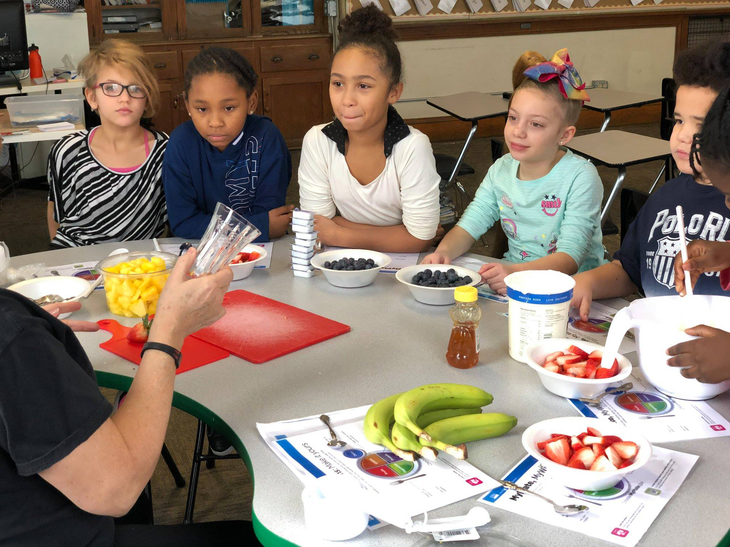
Working hard to bring all our students safely back to school..

Board of Trustees
Constance Ratcliff | Ed Williams
Wayne Patterson | Sonya Adams
Dr. Margaret Smith | Shantel Hillard
Tim Kuzma | Michael Hooks

January 21, 2021
Table of Contents

2. Mid-Quarter Report
3. Academic Updates
10. Human Resources
10. Rise Family Organization Update

2020 – 2021 Mid-Quarter Report
Mid-Quarter Report
- Erie County is currently experiencing its highest daily case counts since the beginning of the COVID-19 pandemic, resulting in an increased number of hospitalizations, deaths, and increase risk for the most vulnerable in our community (PDE, Attestation Letter).
- Erie Rise has elected to follow the State’s recommendation to provide remote-only instruction during this period of Substantial disease transmission until our county has experienced two consecutive weeks of lower than Substantial disease transmission. Currently, Erie County has experienced nine straight weeks of Substantial disease transmission (11/13/20 - 1/8/21).
- Erie Rise will continue to push academics for students, and family safety during the pandemic. The school is preparing a COVID-19 informational packet for families concerning the vaccine program.
- The School is working within state guidelines to provide mandatory dental, vision, and physical exams. These health checks are still required even in a remote learning environment.
- The School is seeking approval for the new security system proposed by Verkada.
- The School is recommending the PGIM QMA Mid Cap Value fund be replaced the fund with the American Century Mid Cap Value fund.

ERLACS Board of Trustees Meeting 1/21/2021

Academic Updates
Erie Rise leadership academy Charter

Participation/Attendance Update
Erie Rise Leadership Academy Charter School has been continuously improving its participation/attendance since the first day of school. Due to targeted communication and support efforts, ERLACS has improved its participation/attendance from September to present whole-school.
The teachers and administration will continue to support students and parents/families to the best of their ability to further increase participation/attendance.

Increasing Student Achievement – 1st Quarter to 2nd Quarter
The administrative team carefully reviewed 1st quarter grades and has since implemented a series of targeted efforts, including “floor grades,” progress reports, and walk-throughs and professional development for teachers, to increase student achievement moving into the 2nd Quarter.
In order to track student progress and achievement, teachers are submitting bi-weekly progress reports for administration to review. The school has decided students will no longer be allowed to not complete or turn in work that has been assigned. Teachers and Aides will work with students to ensure all work is completed. Even if a student does not know an answer, they are to be instructed to write down the reason they could not give an answer or complete a task. This will allow the teacher and instructional coaching team to better assess how to help students.
Furthermore, for any student who has below a C in any class, the teacher will complete the “Below a C” Google Form (below); each student will be assigned a “Family Coach” who will ensure that all missing assignments and additional support are provided to the student via 21st Century, Title 1, Social Services, and/or Community Outreach Resources (i.e. local college students as tutors). In connection with the spreadsheet developed to capture student work not completed, the school has a “No Zero” policy. The policy is designed to eliminate zeros resulting from uncompleted work. Once the work is completed based on the process outlined above, the lowest grade a student can get is 50%. This will not only provide grade fairness, but also allows both good and struggling students to recover from a poor performance.
ERLACS has also successfully moved to a hybrid-like model where students have the option to attend class and receive live instruction from their teachers via Zoom but complete their assignments in a print packet rather than completing assignments online. This allows our students to engage in a more hands-on learning experience and practice penmanship and enhance their fine-motor skills, especially for our younger learners who are developing these skills.

Teacher Effectiveness – Walk-Throughs and Professional Development
Administration has instituted a series of virtual walk-throughs that will be used to drive professional development opportunities for teachers. Walk-throughs are short, formative, informal observations that help administrators and teachers identify what training is needed for on-going improvement; the administrative team successfully completed 3 walk-throughs per teacher before Winter Break. After analyzing these walk-throughs and having discussions amongst the administrative team and with teachers, the administrative team has decided to conduct an additional 4th Walk-Through with an emphasis on student-centered teaching and learning as well as attendance and active participation.
Teachers will be participating in targeted virtual professional development opportunities throughout the month of January including Gale e-Library, General Education – Special Education Collaboration, and more.
Additionally, ERLACS recently added a highly-qualified and experienced Instructional Coach to its Academic Team. Ms. Peggy Conn will be working closely with administration and teachers to increase teacher effectiveness and student achievement via a student-centered approach to teaching and learning.

Virtual Student Incentive Program
A team of teachers and administrators has started the process of identifying resources and programs that will create an academic culture where students can thrive. Kickboard is an online token-economy incentive program aimed at increasing attendance and positive behaviors. Students have opportunities to earn virtual money that can be redeemed for various rewards, much like a school store. Demo’s and price quotes are being reviewed and more information is forthcoming.
Special Education Update
The Special Education Team is in their final steps of closing the Cyclical Review performed last spring a month ahead of schedule. Individualized Zoom classes to meet with the Special Education students have been occurring daily. Overall, our students service time is being met and additional supports are offered as needed. The Special Education Team would also like to formally welcome Mr. Seth Hembree, our new School Psychologist; he has been a tremendous addition to our team!

Human Resources/Compliance Report
January 21, 2021

Human Resources is seeking to fill the following position:
Executive Assistant | Eduardo Tapia

Erie Rise Leadership Academy Charter School
Rise Family Organization Update
December 17, 2020

Special Programs/Activities:

- The RFO is encouraging Families, Teachers, Board Members and the Administration to submit Box Tops to the Rise Office.
- The Erie Rise Title I program will be participating in a virtual Families Turn on to Literacy workshop between January and April, 2021 courtesy of a grant from WQLN.
- Communicating back and forth with John Dahlstrand, Athletic Director for Erie Public Schools. Games have been scheduled for the Erie Rise 6th and 7th/8th grade teams to play Strong Vincent, East and Wilson Middle Schools. Games scheduled in December have been cancelled due to PIAA rules to allow (15) practices prior to game play.
- Pastor Matt Judd at Glenwood United Methodist Church sent the Contract for Erie Rise to use their gymnasium for basketball practices on Tuesday and Wednesday’s from 3:30 – 5:30 p.m. at a cost of $ 60.00. The contract has been sent to the Solicitor for review.
- Ms. Jeffries in partnership with the RFO obtained a $ 500.00 grant from Cafaro Foundation to assist our Homeless and Transitional students.

Upcoming Events

- Box Tops
- Purchase of Christmas items for Rise Homeless and Transitional students.
- Rise basketball starting Monday, January 4, 2021 at 4:00 p.m./5:15 p.m. with Erie Rise vs. Woodrow Wilson Middle School. Rise 7/8 grade boys and second game 5/6 grade boys. The game will be held at Glenwood United Methodist Church, 2931 Myrtle Street, Erie, PA 16508.

 | Erie Rise-Rise Family Organization Treasurer's Report |  |  |  |  |  |  | 1/11/2021
 |  | Savings Account
Beginning Balance as of 12/7/20 |  |  |  |  |  |  | $2,537.54
12/31/2020 |  | Dividend |  |  | $0.22
Ending Balance |  |  |  |  |  |  | $2,537.76
1/11/2021
 | Erie-Rise Family Organiation Treasurer's Report
 |  | Checking Account
Beginning Balance |  |  |  |  |  |  | $3,551.16
12/7/2021
Funds Received:
Go Fund Me Account Donations |  |  |  |  | $3,028.56
Expenses: |  |  |  |  |  |  | $563.58
ATM/Walmart (Gift Cards) |  |  |  |  |  | $500.00
Portratz Floral Shop (Gambill Funeral Expense) |  |  |  |  | $535.29
ATM/Office Supplies |  |  |  |  |  | $63.58
Ending Balance |  |  |  |  |  |  | $2,987.58
1/11/2021

