CEO Report
Educating the Next Generation
Celebrating Black History Month
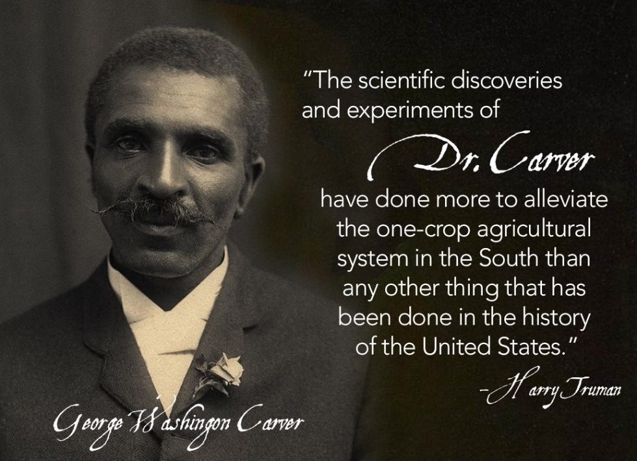
Believed to have been born one year before slavery ended. George Washington Carver became the first African American to earn a Bachelor of Science degree. Rise started in 2011, is asking a similar question today, who will be the first student from Erie Rise to earn a Bachelor of Science degree?
Board of Trustees
Constance Ratcliff | Ed Williams
Wayne Patterson | Sonya Adams
Dr. Margaret Smith | Shantel Hillard
Tim Kuzma | Michael Hooks
February 18, 2021
Table of Contents
2. Third- Quarter Report
3. Academic Updates
14. Human Resources
15. RFO Report
16. RFO Treasurer’s Report

2020 – 2021 Third-Quarter Report
Third-Quarter Report
- The School is requesting that the Board approve changes to our Attestation letter and Phased School Reopening Health and Safety Plan to allow students back in the building starting March 1st. This will allow for some much needed testing, instructions, and mandatory health checks.
- The School is requesting approval to purchase an Express Van to replace the Ryder Truck.
- The resignation letter removing Mr. Lang from the school’s retirement plan committee has been mailed.
- The School’s heating system is being repaired by GECAC. Two boilers are scheduled to be replaced. No completion date is available at this time.
- The school is seeking approval for the air filtration system presented to the Board to provide a high level of protection against COVID 19 for our students, staff and guests in the building. The School is prepared to move now to ensure the system is in place for March 1st. The system has a life beyond COVID in that it cleans the air, meaning students with allergies and other breathing issues will benefit. Improved air quality has been linked to improved test scores and school attendance. (See quote attached).
- The Chrome books have come in and are in the process of being prepared for students.
- The School’s Financial Interests forms are in. We are asking all Board Members to complete the forms and return them as soon as possible. Please watch for the form in the mail. The forms can be dropped off at the School once completed.

ERLACS Board of Trustees Meeting 2/18/2021

Academic Updates
Erie Rise leadership academy Charter
Participation/Attendance Update
Erie Rise Leadership Academy Charter School has been continuously improving its participation/attendance since the first day of school. Due to targeted communication and support efforts, ERLACS has improved its participation/attendance from September to present whole-school.
The teachers and administration will continue to support students and parents/families to the best of their ability to further increase participation/attendance.

December Snapshot – Whole School Data
Week | Whole School Average Attendance Percentage
January 4 - 8 | 87%
January 11 - 15 | 89%
January 18 - 22 | 88%
January 25 - 29 | 90%
February 1 - 5 | 91%
Monthly Average | 89%

Grade Level Weekly Breakdown
January 4 – January 9
Grade | Average Weekly Attendance
Kindergarten | 96%
1st Grade | 92%
2nd Grade | 79%
3rd Grade | 90%
4th Grade | 90%
5th Grade | 89%
6th Grade | 87%
7th Grade | 83%
8th Grade | 82%
Whole School | 87%
January 11 – January 15
Grade | Average Weekly Attendance
Kindergarten | 91%
1st Grade | 89%
2nd Grade | 80%
3rd Grade | 95%
4th Grade | 95%
5th Grade | 90%
6th Grade | 84%
7th Grade | 87%
8th Grade | 87%
Whole School | 89%
January 18 – January 22
Grade | Average Weekly Attendance
Kindergarten | 90%
1st Grade | 80%
2nd Grade | 78%
3rd Grade | 98%
4th Grade | 95%
5th Grade | 91%
6th Grade | 81%
7th Grade | 88%
8th Grade | 88%
Whole School | 88%

January 25 – January 29
Grade | Average Weekly Attendance
Kindergarten | 93%
1st Grade | 90%
2nd Grade | 84%
3rd Grade | 93%
4th Grade | 96%
5th Grade | 92%
6th Grade | 85%
7th Grade | 86%
8th Grade | 89%
Whole School | 90%

February 1 – February 5
Grade | Average Weekly Attendance
Kindergarten | 93%
1st Grade | 89%
2nd Grade | 85%
3rd Grade | 97%
4th Grade | 93%
5th Grade | 93%
6th Grade | 83%
7th Grade | 95%
8th Grade | 94%
Whole School | 91%

Increasing Student Achievement – 1st Quarter to 2nd Quarter Comparison
The majority of classes saw improvement in students’ grades from 1st Quarter to 2nd Quarter as indicated in the tables below. These improvements are due to a number of factors including:
- Implementation of frequent progress reports allowing teachers, students, parents, and administration to more closely monitor grades on a regular basis
- 21st Century After-School Tutoring providing students with targeted support and additional opportunities to complete assignments with support from teachers
- Increased attendance (see attendance numbers above)
- A no zero policy designed to eliminate zeros resulting from uncompleted work. Students are given additional assistance to ensure all work is completed.
- Re-Teach Opportunities designed to ensure student mastery of concepts.
- An improved packet delivery and pickup system was put in place to ensure learning materials were completed and returned.

While some grade levels are starting to show signs of improvement, some grade levels are responding much slower. Getting our students back in school, and aggressively attacking areas of identified weakness will be necessary to show the improvement needed to meet the goals in our Charter Renewal.

Our objective for the 3rd Quarter is to continue to work with low-performing students to identify root causes for low academic performance. Assess our students in March and again at the end of the school year to determine student learning and the best way to improve student learning. To build on what is working and quickly change what is not working. A variety of tools are being used to examine the quality of instruction, academic support, how effectively technology is being used, the effects of attendance, and student learning abilities. The ability to assess our students in March, will give us our best indication of how our students will perform on the PSSA, which the renewal goals are set on.

1st Grade Boys – Ms. Wellmon
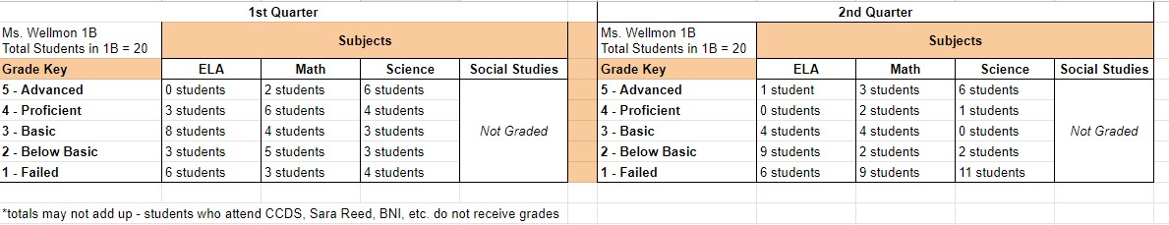

1st Grade Girls – Ms. Steigmeyer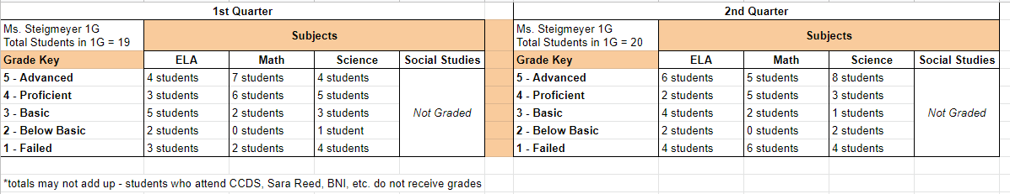

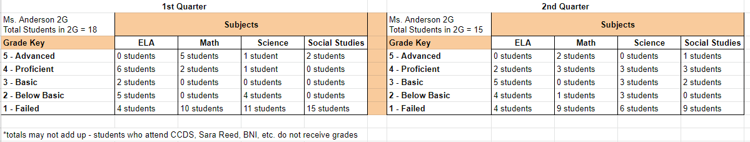
2nd Grade Girls – Ms. Anderson

2nd Grade Boys – Ms. Stephens
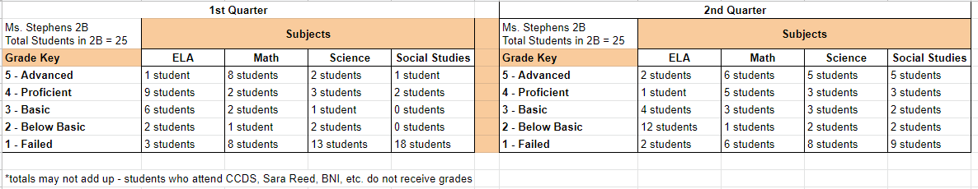

3rd Grade Girls – Ms. Bohen
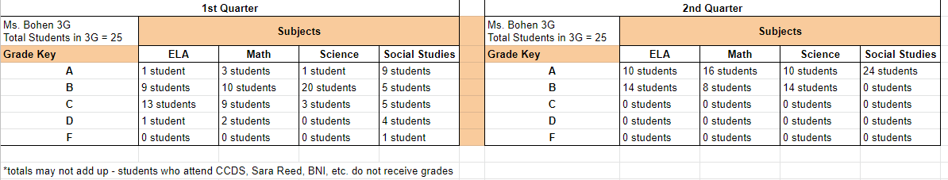

3rd Grade Boys – Ms. Neimeic
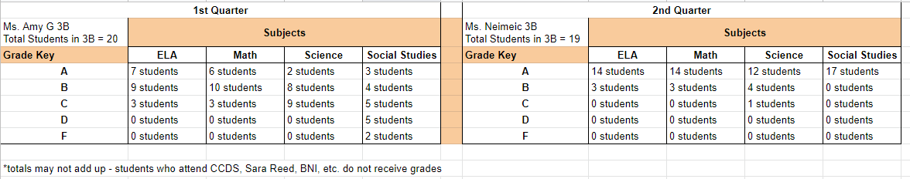

4th Grade Boys – Ms. Carman
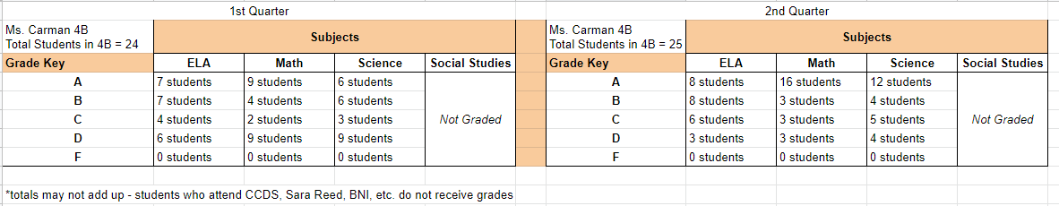

4th Grade Girls – Mrs. Barger
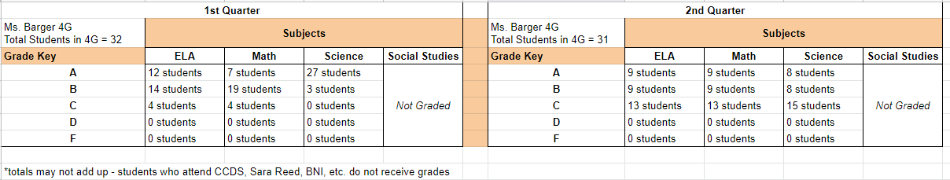

5th & 6th Grade ELA – Ms. Dillard
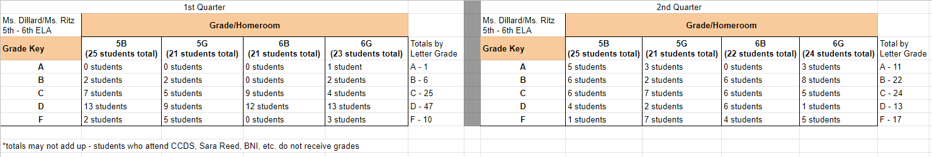

5th & 6th Grade Math – M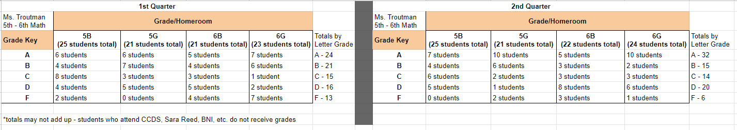s. Troutman

5th & 6th Grade Social Studies
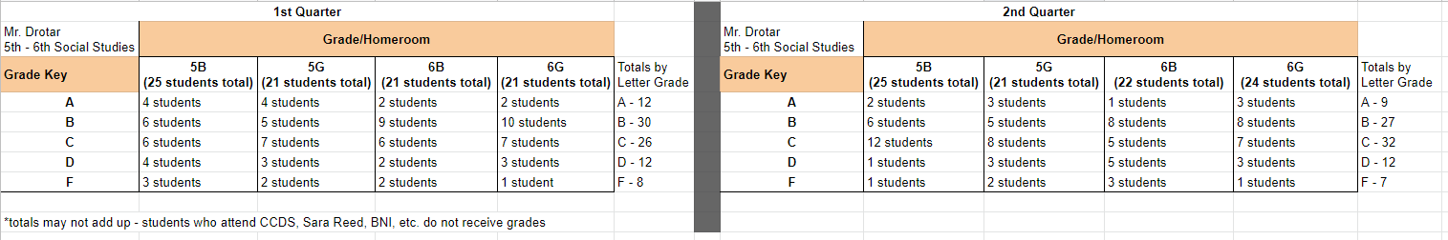

5th & 6th Grade Science – Ms. Bliley
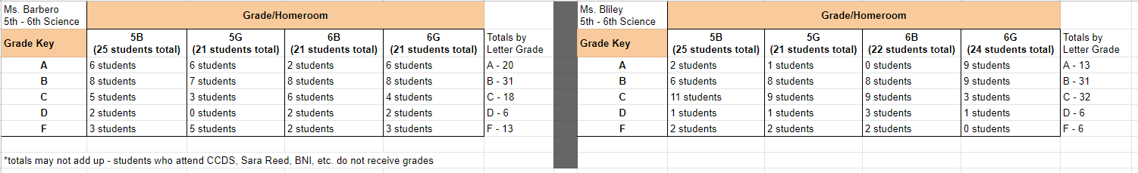

7th & 8th Grade Reading – Mrs. Norgard
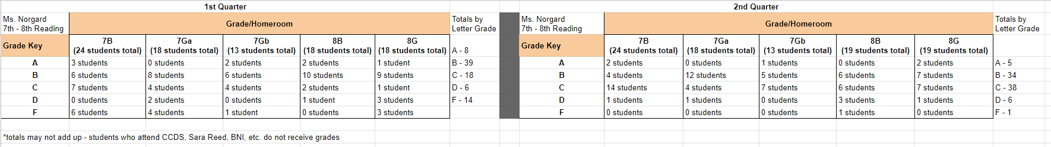

7th & 8th Grade Writing – Mr. Miller
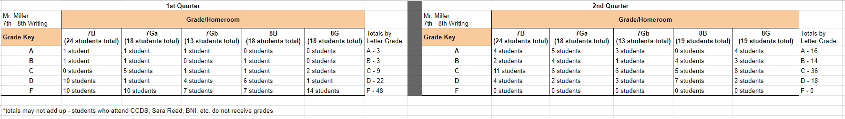

7th & 8th Grade Social Studies – Ms. Alimahmoodi
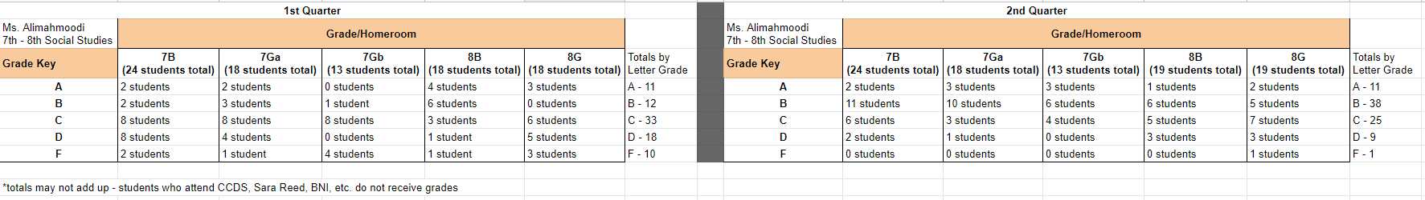

7th & 8th Grade Math – Mrs. Kent
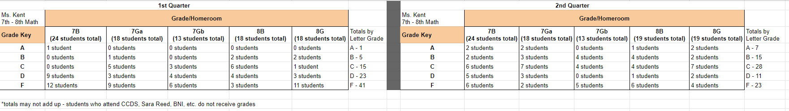

7th & 8th Grade Science – Ms. Amy G
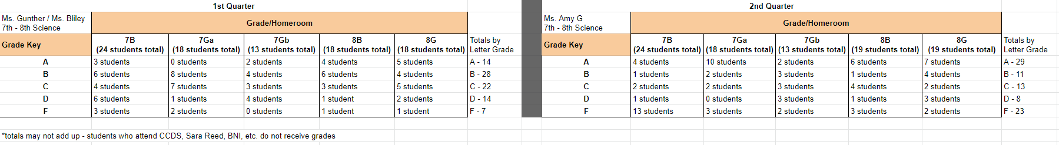

Professional Development Update
Providing teachers with targeted Professional Development opportunities allows them to improve their knowledge and skills which in turn should lead to school-wide improvement, mainly increased student achievement. ERLACS teachers have participated or will participate in the following PD Sessions:

Gale online e-Library | Completed 1/15
Family Engagement | Completed 2/5
Social Emotional Learning | Scheduled for 2/12
Teaching with Poverty in Mind | Scheduled for 2/12
Trauma-Informed Education | Scheduled for 2/19
Universal Design for Learning (UDL) | Scheduled for 2/26
Technology and Other Resources for the Online Classroom | Scheduled for 3/12
Engaging Students in the Online Classroom | TBD
Response to Intervention (RTI) | TBD
Co-Teaching | TBD

Enrollment Update
Grade | Boys | Girls | Total in Grade
Kindergarten | 12 | 10 | 22
1st Grade | 20 | 20 | 40
2nd Grade | 24 | 15 | 39
3rd Grade | 19 | 25 | 44
4th Grade | 24 | 31 | 55
5th Grade | 25 | 20 | 45
6th Grade | 22 | 24 | 46
7th Grade | 24 | 30 | 54
8th Grade | 19 | 19 | 38
Total | 189 | 194 | Grand Total 383
Pending Enrollments: 3 (KG, KB, & 7G)

Human Resources/Compliance Report
February 18, 2021

Human Resources is seeking to fill the following position:
5 & 6 Grade ELA | Dr. Noelle Jacqueline
5 & 6 Grade ELA | Lauren Schroeder
5 & 6 Grade Science | Sadie Brown
Bus Driver | Richard Rondeau
Resignations
Marie Renshaw (Nurse) 2/5/21 | Nick Burke (Maintenance) 1/21/21

Erie Rise Leadership Academy Charter School
Rise Family Organization Update
February 18, 2021

Special Programs/Activities:

- The Title I Program held their annual meeting on Friday, January 8, 2021 via zoom at 12:00 noon. The Title I staff reviewed Title I policies, testing updates and answered general Title I questions.
- The RFO is encouraging Families, Teachers, Board Members and the Administration to submit Box Tops to the Rise Office.
- The Erie Rise Title I program will be participating in a virtual Families Turn on to Literacy workshop between January – April 2021 courtesy of a grant from WQLN.
- The Social Service Department in conjunction with the Deaconess Ministry of Greater Bethlehem Temple Church distributed hats, scarves and gloves to (9) Erie Rise Families reaching (30) Erie Rise students.
- The RFO received donations of new and slightly used coats from the BTW Center that were distributed to Rise Families. made sure that families had food for Thanksgiving and Christmas
- In conjunction with the Principal, finalized funds raised to assist the Gambill Family. Funds were used to from the Go Fund Me Account to pay for Floral arrangements and a headstone.
- The RFO in conjunction with the Board of Trustees is proposing to award (2) Erie Rise Alumni Scholarships. The scholarship is available to Erie Rise graduates (Class of 2017) who will be graduating from High School in 2021. The Erie Rise Alumni Scholarship is one of the scholarships available through the My Brother’s Keeper Scholarship application.
- Due to COVID-19 restrictions, the Erie Rise Winter Basketball program has been cancelled.

Upcoming Events

- Box Tops
- Deadline for the 2nd Annual Erie Rise Alumni Scholarship is April 1, 2021.

 | Erie Rise-Rise Family Organization Treasurer's Report |  |  |  |  |  |  | 2/8/2021
 |  | Savings Account
Beginning Balance as of 1/11/21 |  |  |  |  |  |  | $2,537.76
1/31/2021 |  | Dividend |  |  | $0.22
Ending Balance |  |  |  |  |  |  | $2,537.98
2/8/2021
 | Erie-Rise Family Organiation Treasurer's Report
 |  | Checking Account
Beginning Balance |  |  |  |  |  |  | $2,987.58
1/11/2021
Funds Received: |  |  |  |  |  |  | $25.00
Save Around Booklet (P. Jeffries) |  |  |  |  | $25.00
Expenses: |  |  |  |  |  |  | $131.75
ATM/Little Caesar's (Baskeball Team Gathering) |  |  |  |  |  | $31.75
Save Around Booklet Sale Fees |  |  |  |  |  | $100.00
Ending Balance |  |  |  |  |  |  | $2,880.83
2/8/2021
 |  | Go Fund Me Account (Gambill Family)
Beginning Balance |  |  |  |  |  |  | $2,493.27
1/11/2021
Expenses
Ericson Memorial Studios (Headstone) |  |  |  |  |  | $2,493.27
Ending Balance |  |  |  |  |  |  | $0.00
2/8/2021

